Software Requirements Specification

for

Smart Wheel chair

Prepared by

Muhammad Shahzad Ahsan (2016-CE-030)

Syed Maaz Ali (2016-CE-028)

Muhammad Noman (2016-CE-038)

Ehtasham Ali (2016-CE-005)

March 10, 2019

Table of Contents

Table of Contents ii

1. Introduction 1

1.1 Purpose 1

1.2 Intended Audience and Reading Suggestions 1

1.3 Product Scope 1

1.4 References 1

2. Overall Description 1

2.1 Product Perspective 1

2.2 Product Functions 1

2.3 Operating Environment 2

2.4 Assumptions and Dependencies 2

3. External Interface Requirements 2

3.1 User Interfaces 2

3.2 Hardware Interfaces 2

3.3 Communications Interfaces 3

4. System Features 3

4.2 Tasks ………………………………………………………………………………………………..3

4.1 UML Diagram ..................................................................................................................................4

5. Other Nonfunctional Requirements 4

5.1 Performance Requirements 4

5.2 Safety Requirements 4

5.3 Security Requirements 4

# Introduction

## Purpose

The purpose of this document is to build automatic wheel chair and its user guidance.

## Intended Audience and Reading Suggestions

This project is a prototype for the automatic wheel chair and it is restricted within the university Premises. This has been implemented under the guidance of university professors. This project is useful for the all handicap persons.

## Product Scope

The purpose of the automatic wheel chair is to ease handicap persons and to create a convenient and easy to use. The system is based on voice recognition and sensors. We hope to provide a comfortable user experience along with the best pricing available.

## Overall Description

## Product Perspective

Smart wheelchair is generally equipped with sensors, cameras and computer-based system as main processing unit to be able to perform specific task. smart wheelchairs are controlled by human user interface where the human makes decisions at the highest level of operation and the smart control technology makes the rest of the motion automatic.But at the same time we have some disadvantage is that it can,t work in noise environemt , it can only understand English at the same time it have some distance which it will work on it, otherwise a long distance from user to wheel chair make some sort for the user.

In hand gestures it will only work for five finers not less then that.

## Product Functions

## Smart Wheel Chair is mechanically controlled devices designed to have selfmobility with the help of the user command. This reduces the user’s human effort and force to drive the wheels for wheelchair .Furthermore it also provides an opportunity for visually or physically impaired persons to move from one place to another. Smart wheelchair has gained a lot of interests in the recent times. These devices are useful especially in transportation from one place to another. The machines can also be used in old age homes where the old age persons have difficulty in their movements. The devices serve as a boon for those who have lost their mobility. Different types of smart wheelchair have been developed in the past but the new generations of wheelchairs are being developed and used which features the use of artificial intelligence and hence leaves a little to tinker about to the user who uses the wheel chair.

## Operating Environment

Operating environment for automatic wheelchair is listed below:

* Arduino Software
* Arduino IDE
* Operating System: Windows
* Language Used: C#

## User Interfaces

The user interface will be designed keeping the modern aesthetic trends in mind. The user interface will be made in a way which will be simple to use. However, it shall be carefully monitored and kept up to the latest aesthetic trends

## Hardware Interfaces

Hardware Required:

* Ardunio UNO
* Ardunio Nano
* ADXL 355 or mpu 6050
* Jumper Cable
* Chassis
* Gyroscope Sensor
* Motor Shield / 300 RPM Motor
* 2298N Module
* Bluetooth Module HC-05

## Communications Interfaces

Smart wheelchair is generally equipped with sensors, cameras and computer-based system as main processing unit to be able to perform specific task. smart wheelchairs are controlled by human user interface where the human makes decisions at the highest level of operation and the smart control technology makes the rest of the motion automatic.But at the same time we have some disadvantage is that it can,t work in noise environemt , it can only understand English at the same time it have some distance which it will work on it, otherwise a long distance from user to wheel chair make some sort for the user.

In hand gestures it will only work for five finers not less then that.

# System Features

## Tasks

User thinks of several tasks:

1. Forward movement of fingers
2. Right movement of fingers
3. Left movement of fingers
4. Forward movement by voice
5. Left movement by voice
6. Right movement by voice
7. Stop

These tasks are to be mapped in wheel chair

## UML DIAGRAM

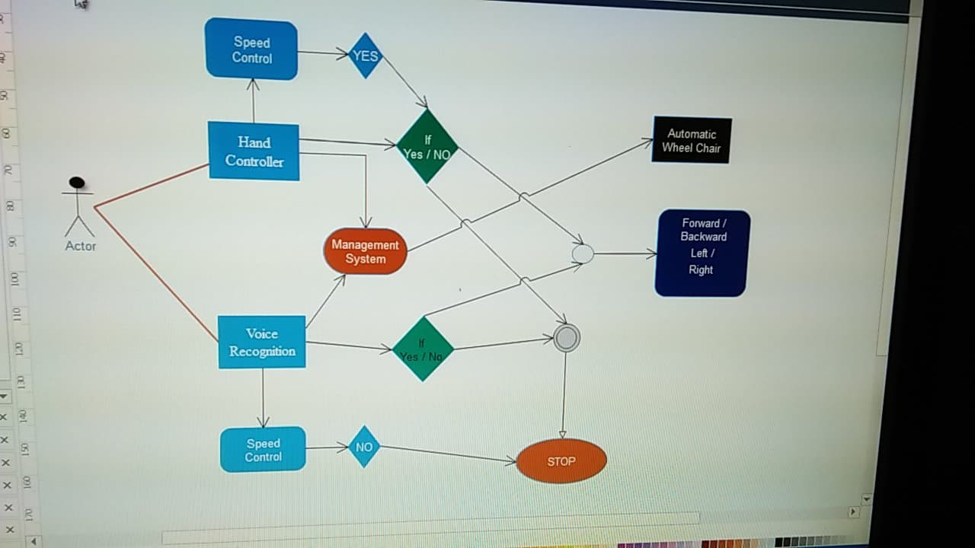

# 

# Other Nonfunctional Requirements

## Performance Requirements

## Smart Wheel Chair is mechanically controlled devices designed to have selfmobility with the help of the user command. This reduces the user’s human effort and force to drive the wheels for wheelchair .Furthermore it also provides an opportunity for visually or physically impaired persons to move from one place to another. Smart wheelchair has gained a lot of interests in the recent times. These devices are useful especially in transportation from one place to another. The machines can also be used in old age homes where the old age persons have difficulty in their movements. The devices serve as a boon for those who have lost their mobility. Different types of smart wheelchair have been developed in the past but the new generations of wheelchairs are being developed and used which features the use of artificial intelligence and hence leaves a little to tinker about to the user who uses the wheel chair.

## Safety Requirements

People use wheelchairs for a variety of reasons. This popular and safe mobility device is meant to provide the user with independence, comfort and the capability to enjoy life to the fullest. using a wheelchair is easy, and for the most part it is. However, there are a variety of safety measures you will want to consider and follow to assure you are getting the best use out of your wheelchair. We have put together this useful wheelchair safety guide to help you avoid any accidents, preventing falls and other safety tips.

## Security Requirements

There are a variety of wheelchairs that are excellent for outdoor use. However, you will always want to be careful and avoid certain surfaces and weather conditions. Sandy surfaces should be avoided as much as possible. Even a paved sidewalk with a small amount of sand scattered on it can cause your wheelchair to become unbalanced, spin around and tip over. This happens very quickly and mostly with power wheelchairs. Sometimes you are able to gain control and prevent the fall, but this is risky. To prevent this from happening try to avoid the sandy surface by going around the surface. Wet surfaces and puddles should also be avoided.

Avoiding the wet surface and going around the area is recommended for safety reasons.